i2b2 Admin Tool and Data Steward Documentation

By: Matthew Joss

**Read Me:**

This document consists of 2 sections. The first section is centered on how to use the i2b2 Admin Tool, and the second section is centered on how to use the Data Steward. The i2b2 Admin Tool enables an administrator to create new users, connect them to a directory service, and add users to i2b2 projects. The Data Steward is primarily used by managers to audit query logs, and it can also be used by users in order to create new query topics.

Feel free to jump ahead to the “Using the Data Steward as a User” subsection within Section 2 if you are a user trying to choose and create a new query topic. Also if you are a manager trying to audit a query log, you can jump ahead to the “Using the Data Steward as a Manager” subsection. Also, take note that the Data Steward Application does not work in Internet Explorer Version **IE 11.0.9600.18537** and thus it is necessary to use a different version or a different web browser such as Chrome, Firefox, or Safari.

Section 1: How to Use the i2b2 Admin Tool

The i2b2 Admin Tool enables an administrator to create new users, connect them to a directory service, and add users to i2b2 projects. This section consists of the following 4 subsections:

* Log in to the i2b2 Admin Tool
* Creating a New User
* Creating and Modifying User Parameters
* Adding users to projects.

**Log in to the i2b2 Admin Tool:**

To log in, go to: http://<youri2b2site>/admin and log in using your standard i2b2 user ID and password. For example, at Partners our URL would be [http://i2b2pcoriappprod.dipr.partners.org/admin/](https://owa.partners.org/cvpn/aHR0cHM6Ly9wcm94eS1vd2EucGFydG5lcnMub3Jn/owa/redir.aspx?SURL=BstDWWdvFJzosB7dvG0ZTRXUVF2r3WhEqQ3Mar-AMjzu1UEilh_UCGgAdAB0AHAAOgAvAC8AaQAyAGIAMgBwAGMAbwByAGkAYQBwAHAAcAByAG8AZAAuAGQAaQBwAHIALgBwAGEAcgB0AG4AZQByAHMALgBvAHIAZwAvAGEAZABtAGkAbgAvAA..&URL=http%3a%2f%2fi2b2pcoriappprod.dipr.partners.org%2fadmin%2f) .

**Creating a New User:**

Usernames are used to log in to i2b2. Also the administrator can add users to projects through manipulation of these usernames.

Adding Users Step 1: Once you have logged into the admin tool, click on ‘Manage Users’ in the left hand column. A drop down menu beneath ‘Manage Users’ will display a list of all registered users. This will also reveal an “Add New User” button in the center console, which is highlighted with a red box in the image below.

Adding Users Step 1:

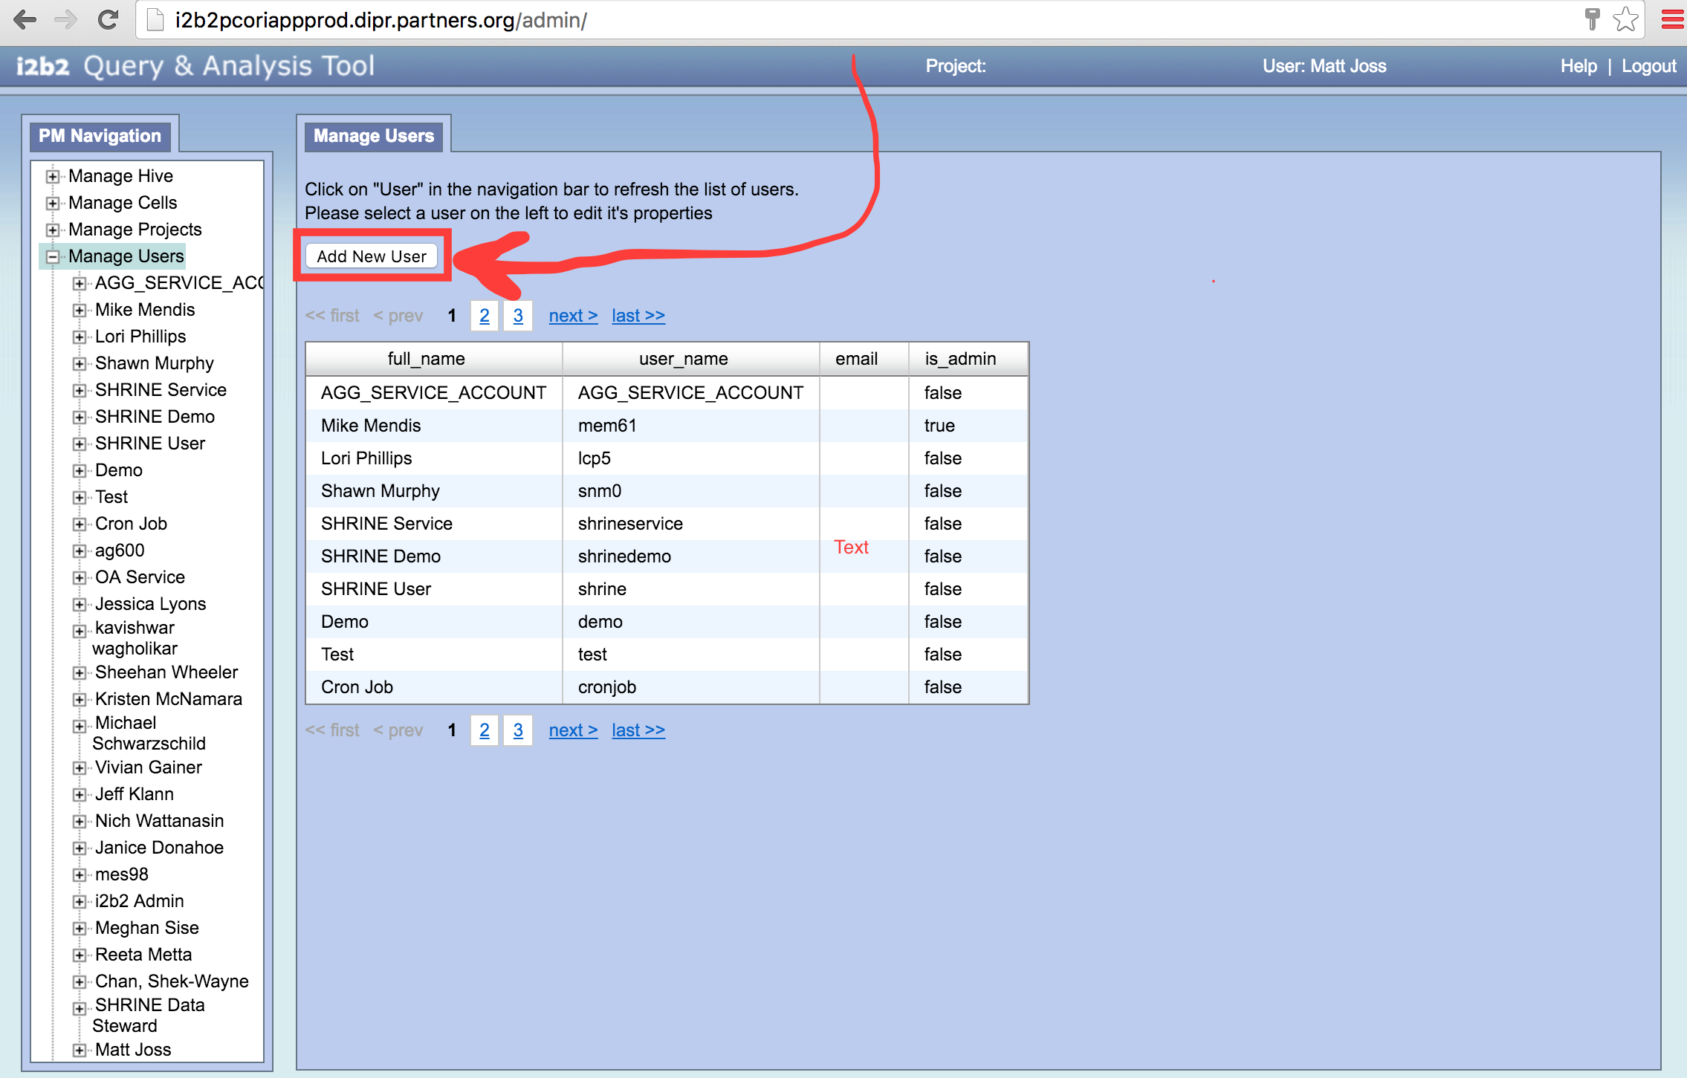

Adding Users Step 2: Click on the ‘Add New User’ Button to create a new user. This will bring you to a page where you can enter the user information for the new user. Data fields include the username and user password, and optionally the user’s name and user’s email address. The password you enter here will be ignored if you later link the user to a directory server. Enter a dummy password, such as ‘password’ in order to save the new user. The ‘is admin’ field is used to let other users manage users and projects. Once this information has been entered, click the ‘Save’ button to save the user.

Adding Users Step 2:

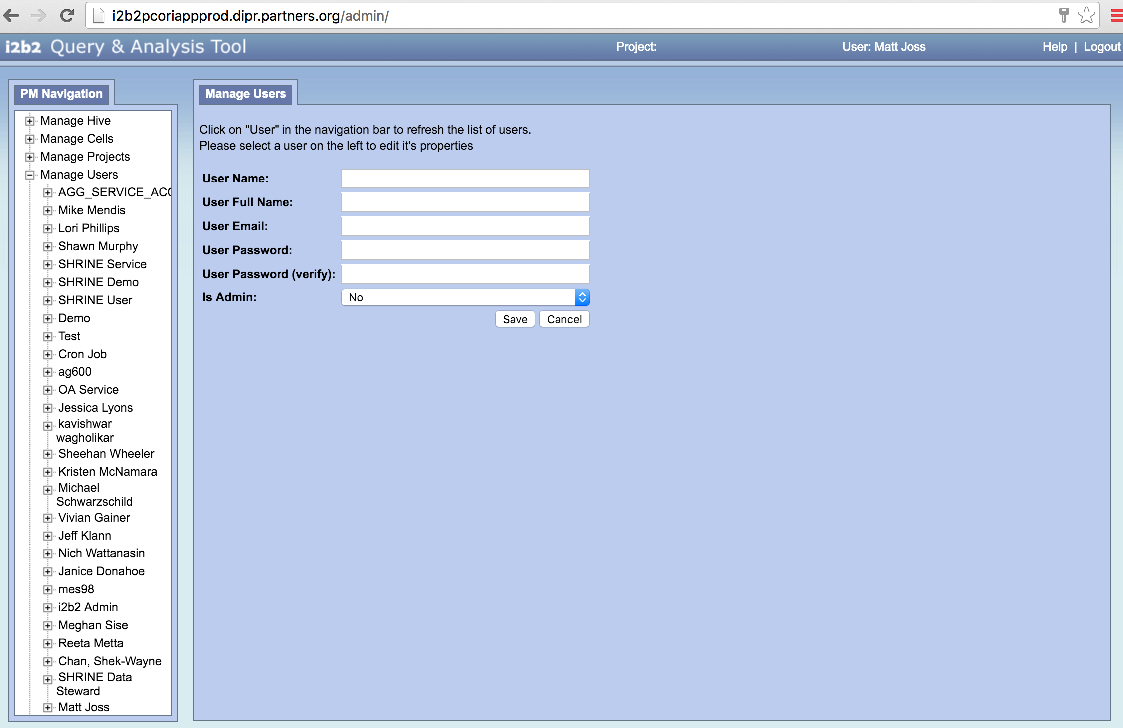

**Creating and Modifying User Parameters:**

In order to link the user to a directory server, the administrator will need to create new parameters for the user. This section describes how to create new parameters, as well as how to modify existing parameters, and which parameters to create in order to link the user to a directory server. **Administrators only need to follow the steps below if your users’ passwords will come from a directory server.**

Creating and Modifying User Parameters Step 1: In the ‘Manage Users’ Directory on the left, click on a registered user to reveal more sub-folders. This will also reveal the user’s roles in the center of the console. Make sure to check the same boxes shown below, as other potential role settings are not yet supported.

Creating and Modifying User Parameters Step 1:

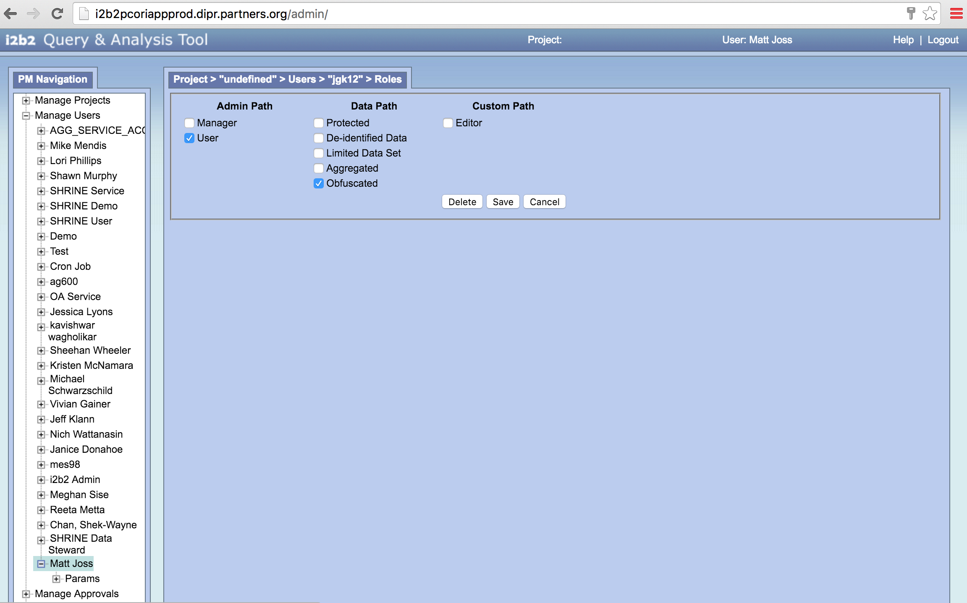

Creating and Modifying User Parameters Step 2: Click on the ‘Params’ sub-folder. The ‘Add New Parameter’ button is located in the center window of the console. Click this button to create a new parameter for this user.

Creating and Modifying User Parameters Step 2: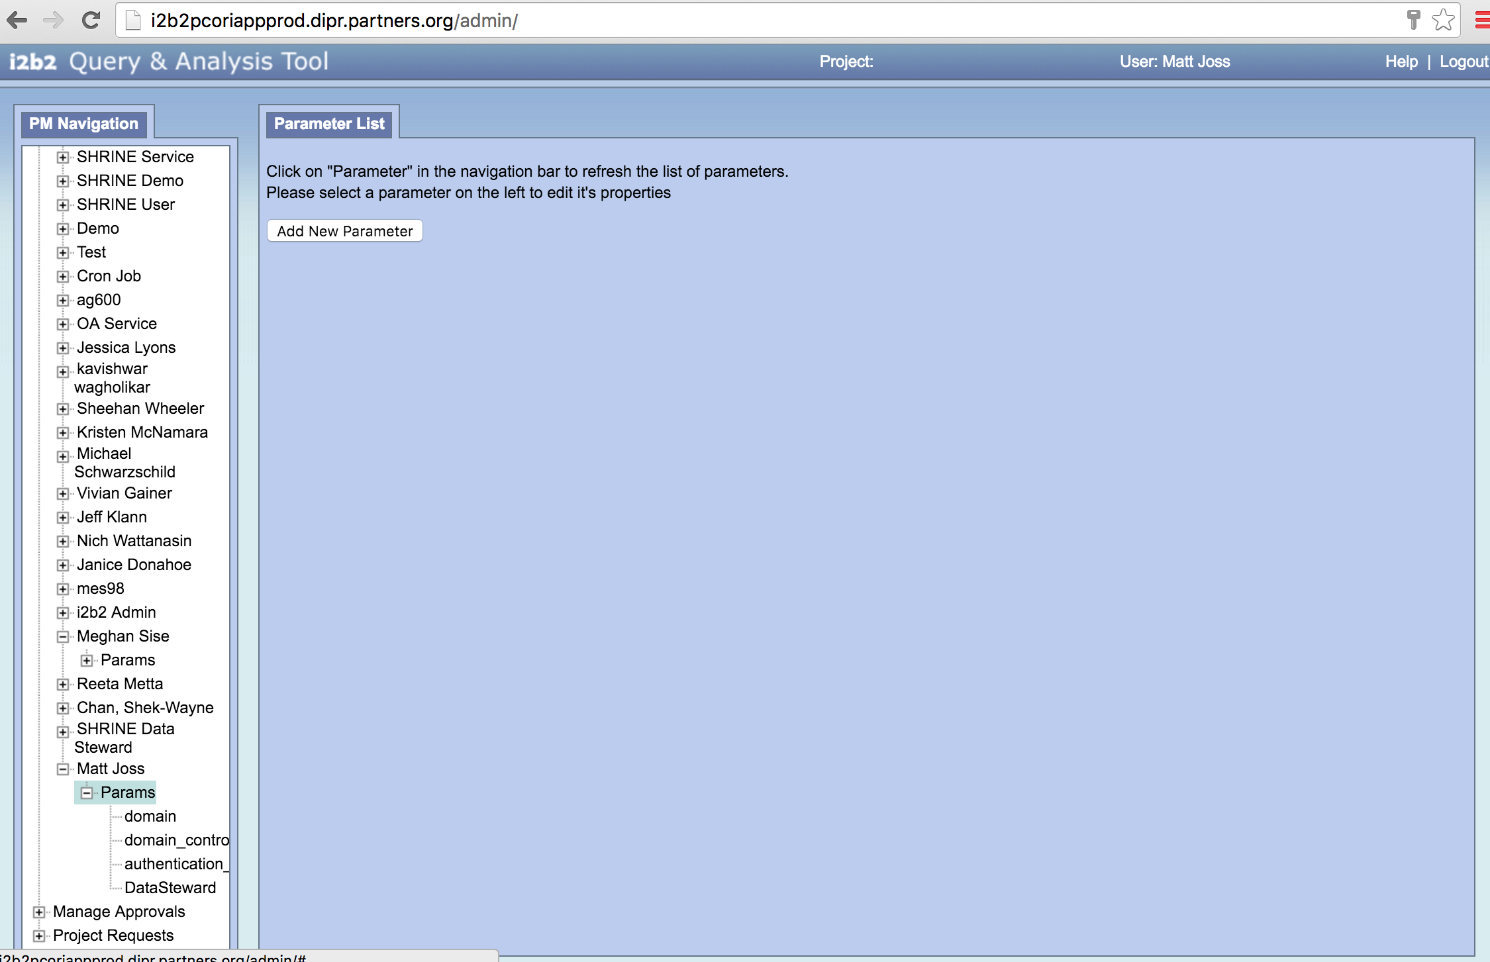

Creating and Modifying User Parameters Step 3: Enter values for the “Parameter Name” and “Parameter Value” as well as choose a parameter data type. If you are trying to connect to a directory service, then refer to Step 5 for the values to enter into these fields. Make sure to click the “save” button to save your changes to the parameter.

Creating and Modifying User Parameters Step 3:

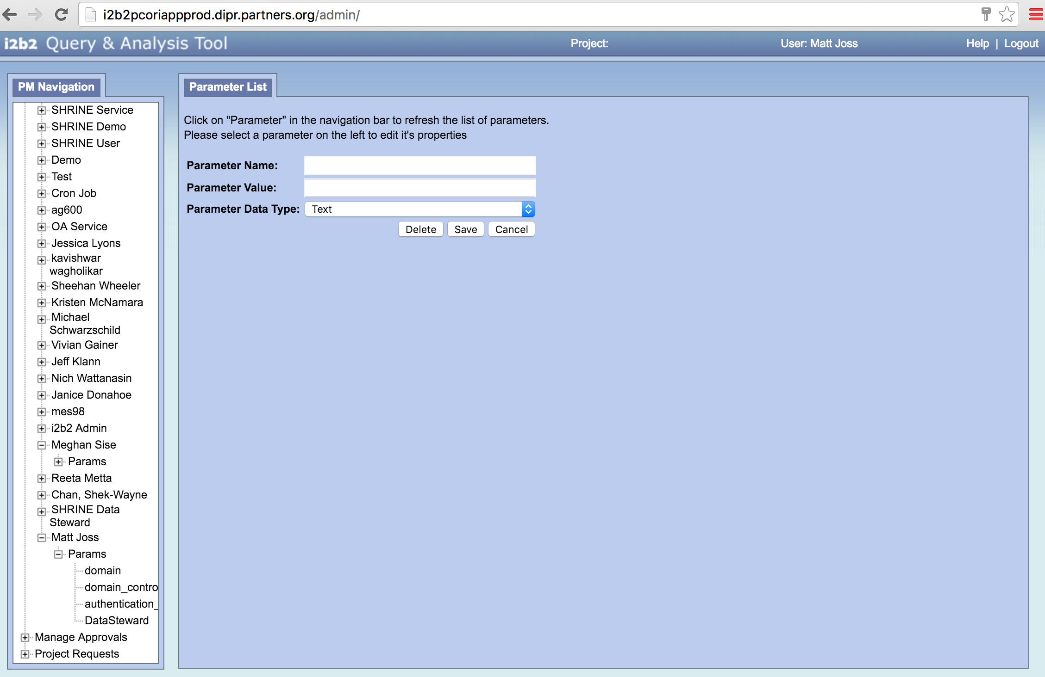

Creating and Modifying User Parameters Step 4: In order to modify an existing parameter, first click on the ‘Params’ sub-folder to drop down the parameters associated with a user. Then, double-click on an existing parameter to display the values associated with that parameter. You can modify these values according to what specifications are needed. Click the “Save” button to save any changes made to the parameter.

Creating and Modifying User Parameters Step 4:

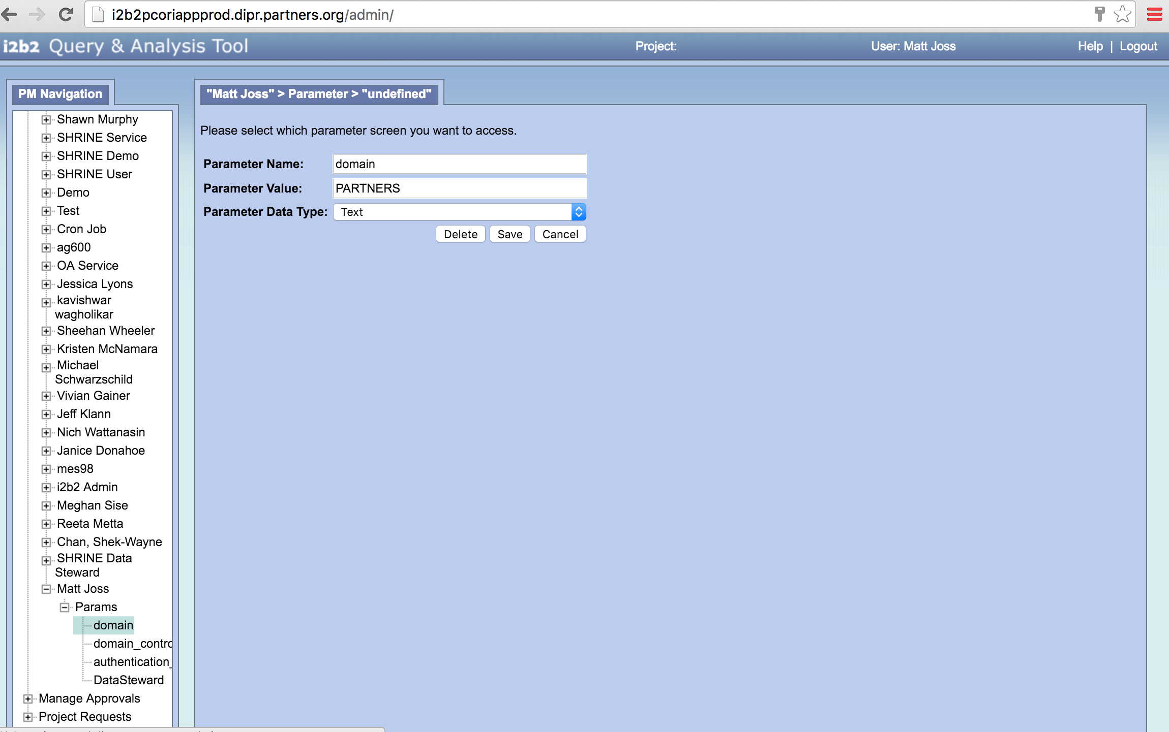

Creating and Modifying User Parameters Step 5: In order to link to a server directory, create the following parameters: **domain, domain_controller, and authentication_method**. The specifications for these 3 required parameters are shown below in the following 3 images. If you are having difficulty setting up a connection from your particular site, you can contact your IT department for help.

Creating and Modifying User Parameters Step 5; domain: This is the user’s Windows domain.

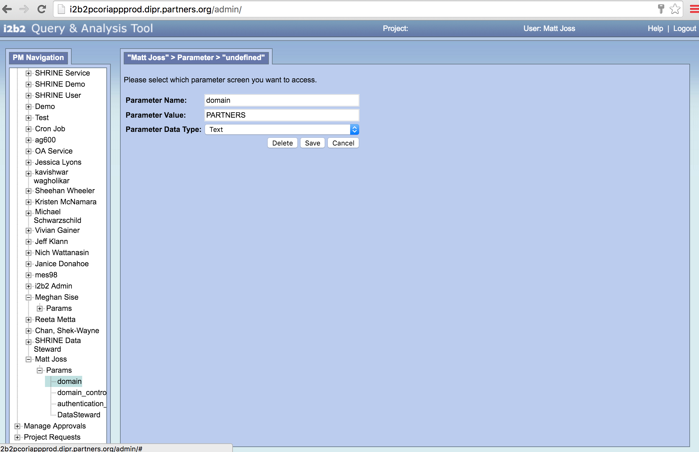

Creating and Modifying User Parameters Step 5; domain_controller: This is the URL of the domain controller.

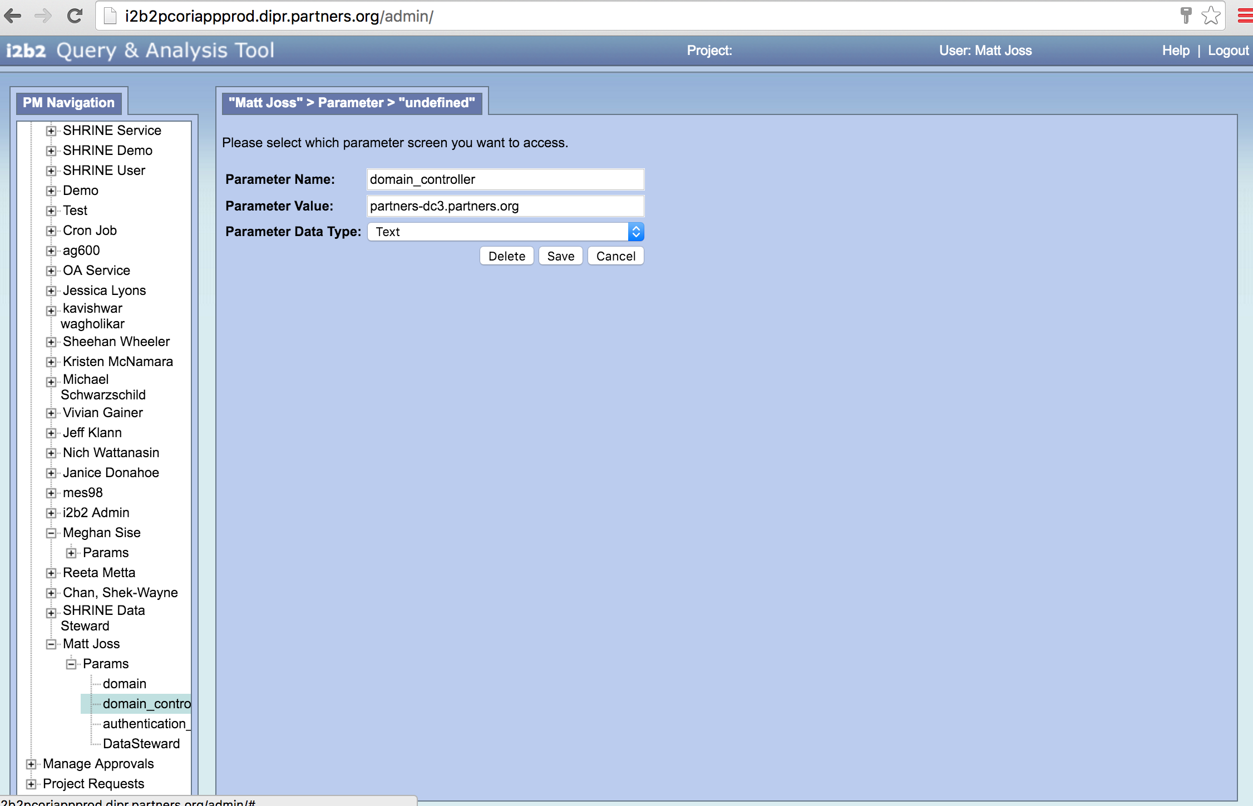

Creating and Modifying User Parameters Step 5; NTLM for Windows:

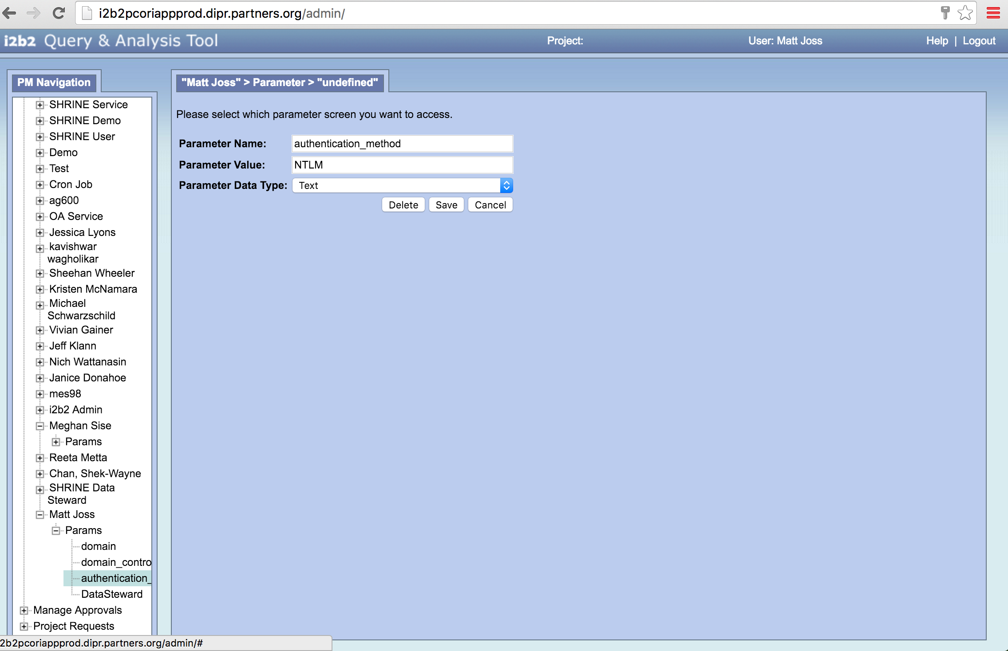

**Adding Users to Projects:**

An administrator may wish to add a new user to a i2b2 project, such as the SHRINE PCORI project. Follow these steps in order to add a new user to a project.

Step 1: On the left hand side of the screen under PM Navigation, there is a ‘Manage Projects’ Directory. Click on this directory to reveal the drop down list of all registered projects. If you want to manage SHRINE access in SCILHS, then you are probably looking for a SHRINE PCORI project.

Adding Users to Projects, Step 1:

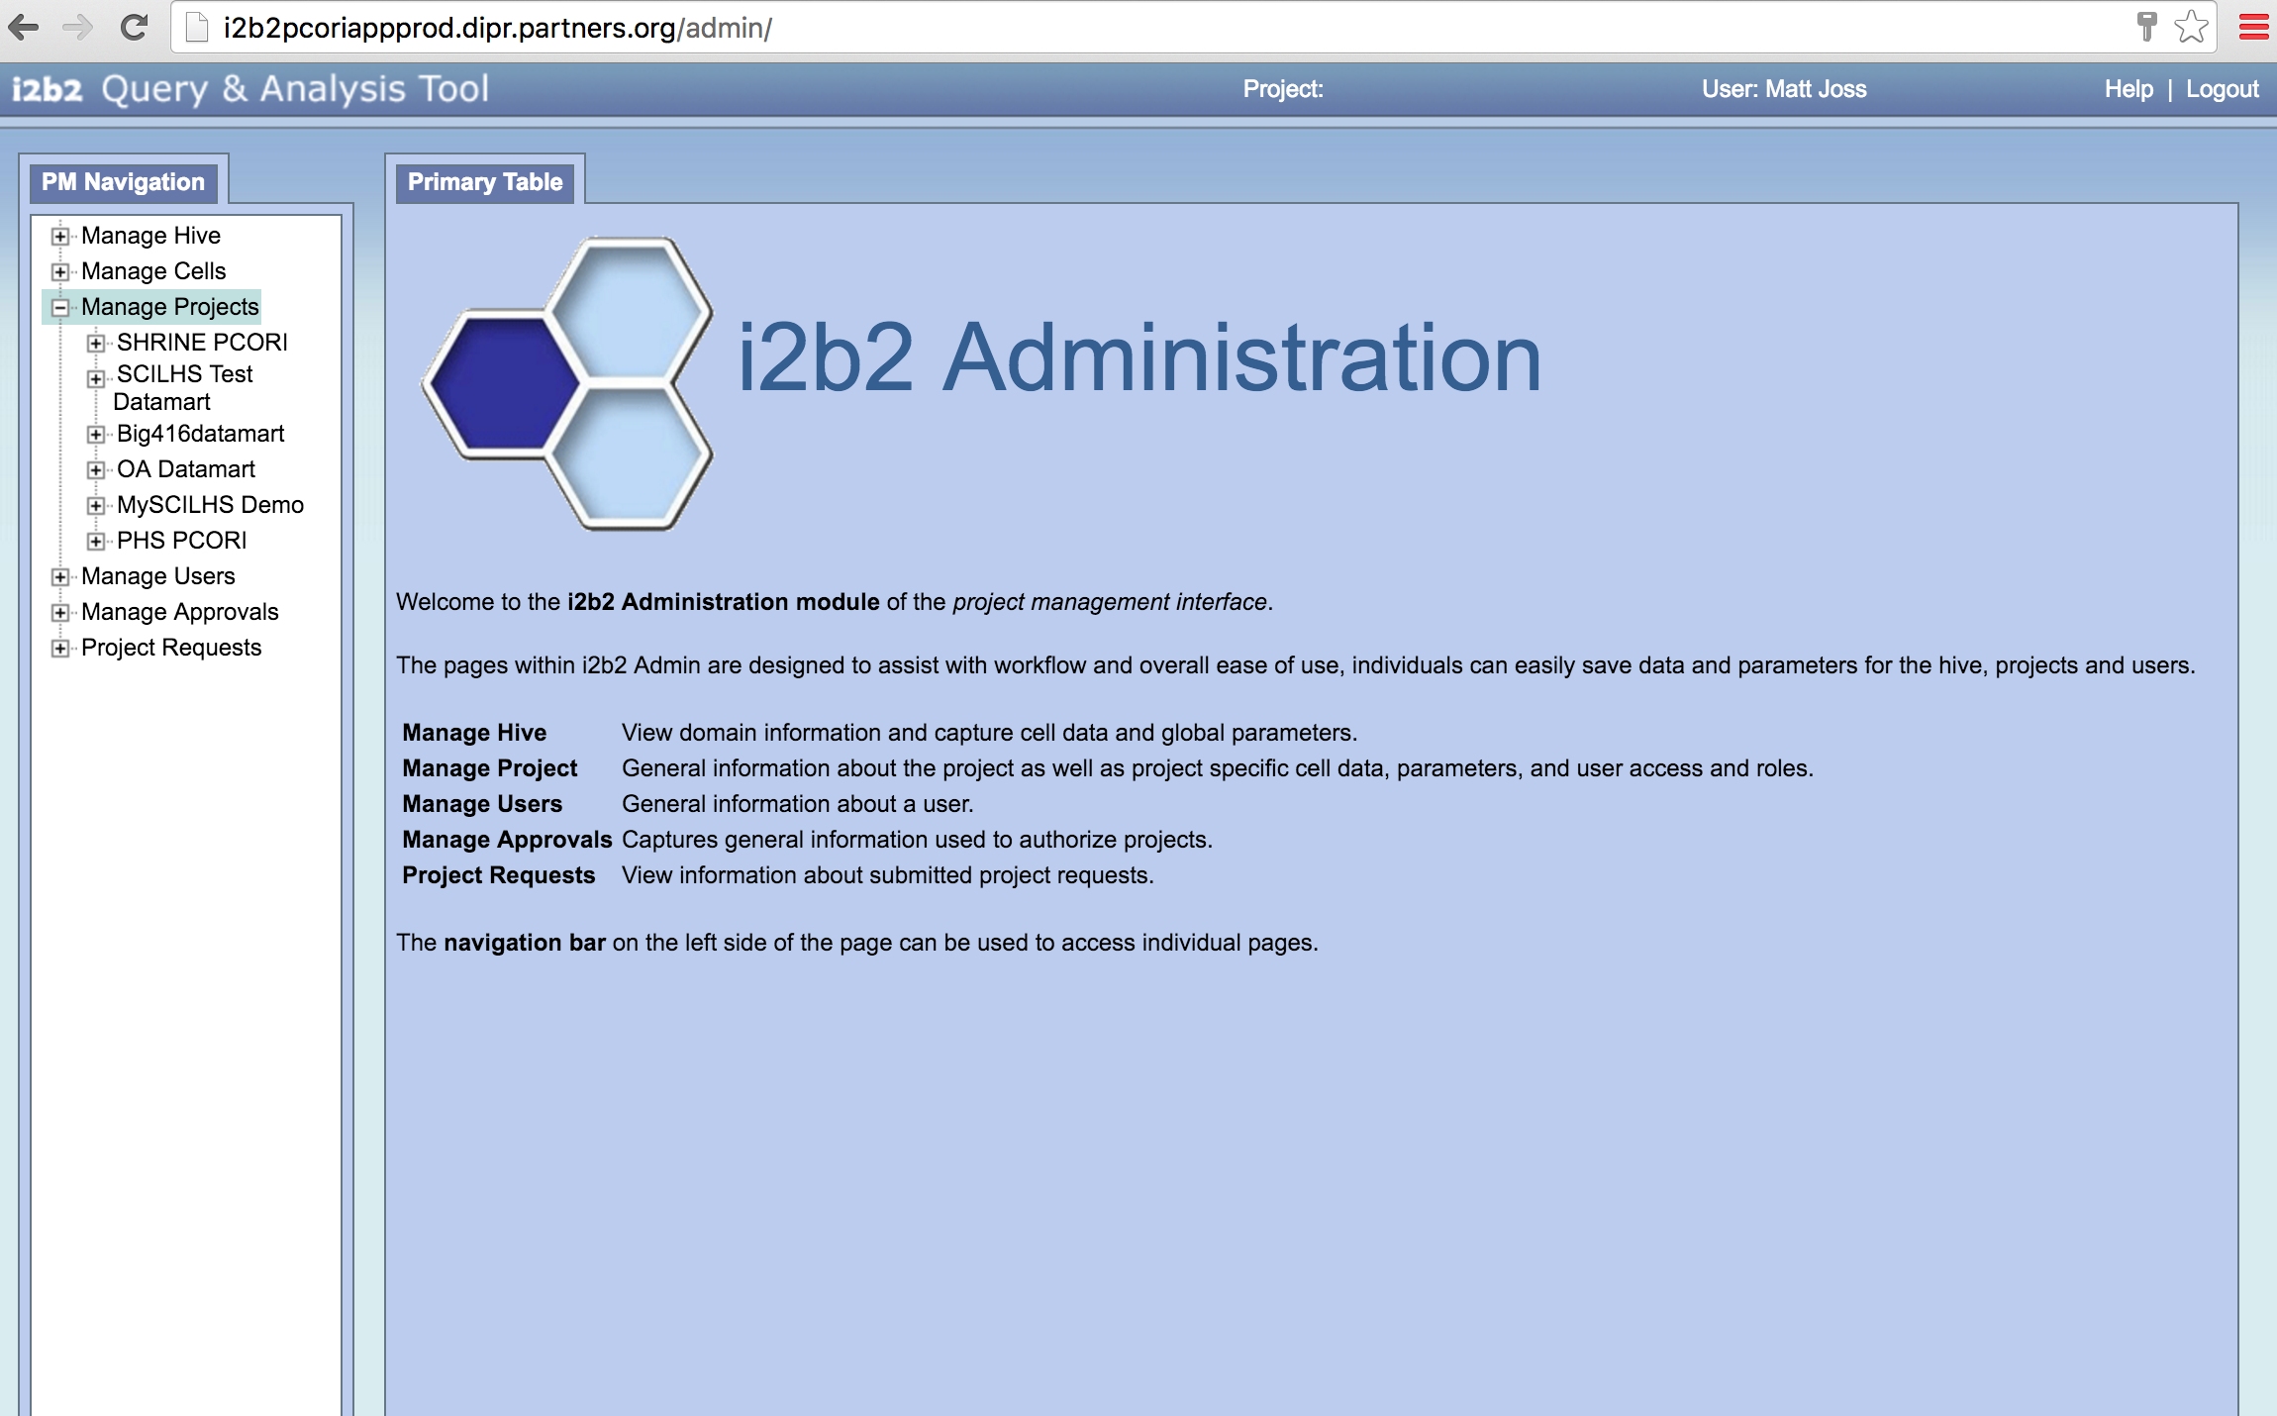

Adding Users to Projects Step 2: Click on a project name to display another set of sub-folders related to that project. Double click the “Users” directory to reveal a dialogue with a button called “Add User to Project” in the center window. Click on this button to add a user to a project. There, you can enter a username to add to that project.

Adding Users to Projects Step 2:

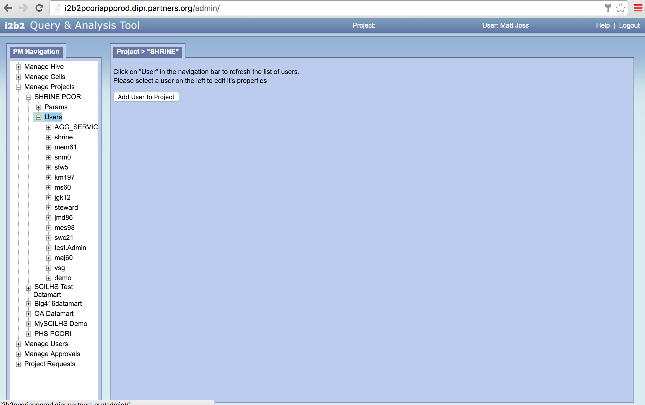

Adding Users to Projects Step 3: A list of the users previously added to this project is listed under the ‘Users’ directory. Click on a username to reveal more subdirectories associated with the user. To change a user’s roles associated with this project, click on the ‘Roles’ subdirectory listed under the user.

Adding Users to Projects, Step 3 and Step 4:

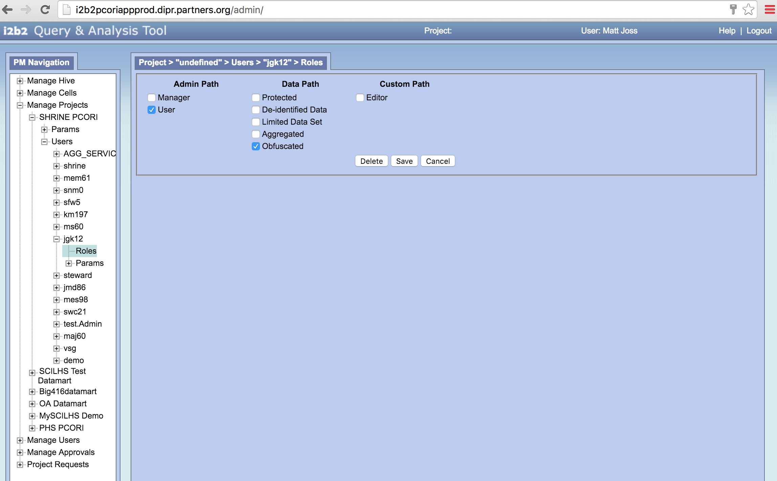

Adding Users to Projects Step 4: There are boxes in the center console that you can check or uncheck in order to change that user’s roles for this project. However, for SHRINE, currently only two of these boxes are functional. To ensure that users are configured correctly in a SHRINE project, make sure that only the ‘User’ box and the ‘Obfuscated’ box are checked. Leave all other boxes unchecked. Make sure to click the ‘Save’ button when you are finished.

The other check box options potentially work for other i2b2 projects. Note that the ‘manager’ option for users should be limited to a select few, whereas most users should be standard users. Managers can edit users and projects.

Section 2: How to use the Data Steward Application

The Data Steward is used by managers to audit query logs, and it can also be used by users in order to create new query topics. Remember that the Data Steward Application does not work in Internet Explorer Version **IE 11.0.9600.18537.** This section consists of the following 2 subsections:

* Using the Data Steward as a ‘Manager’
* Using the Data Steward as a ‘User’

**Using the Data Steward as a ‘Manager’:**

The main role of the data steward is to make sure that any given query is pertinent to the topic it is assigned to. This is called “auditing the query logs.” For more information on what a topic is, you can refer to the next subsection called ‘Using the Data Steward as a User.’

In order to audit the query logs, you will first need to log into the Data Steward Web Client:

Log in to http://<youri2b2site>/shrine-webclient/# using your standard i2b2 user ID and password. For Partners, our link would be:

[http://shrinepcoriappprod.dipr.partners.org/shrine-webclient/#](https://owa.partners.org/cvpn/aHR0cHM6Ly9wcm94eS1vd2EucGFydG5lcnMub3Jn/owa/redir.aspx?SURL=LFy5M9CK0BvEcxoiFjO_dJe8SinLyw1KTRrG_gWGPBLu1UEilh_UCGgAdAB0AHAAOgAvAC8AcwBoAHIAaQBuAGUAcABjAG8AcgBpAGEAcABwAHAAcgBvAGQALgBkAGkAcAByAC4AcABhAHIAdABuAGUAcgBzAC4AbwByAGcALwBzAGgAcgBpAG4AZQAtAHcAZQBiAGMAbABpAGUAbgB0AC8AIwA.&URL=http%3a%2f%2fshrinepcoriappprod.dipr.partners.org%2fshrine-webclient%2f%23) . Select your ‘SHRINE PCORI’ project and you will be directed to the web client.

Data Steward Management Step 1: Once logged into the web client, click on the ‘Request New Topic’ button near the center of the console to perform the audit. Once the user clicks this button, he/she will be redirected to the SHRINE Data Steward login page.

Data Steward Management, Step 1:

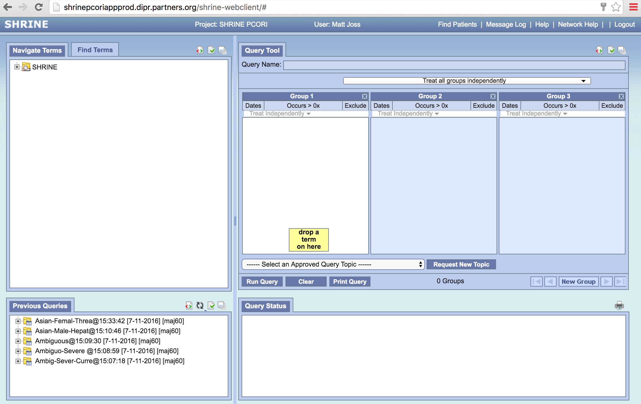

Data Steward Management Step 2: Enter your standard i2b2 username and password here and click the arrow to log in.

Data Steward Management, Step 2:

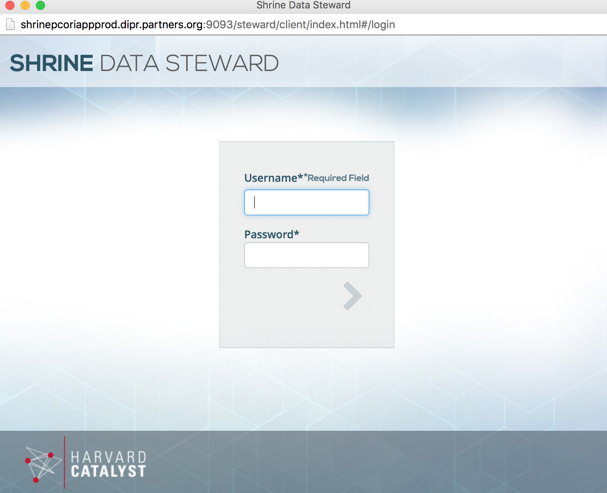

Data Steward Management Step 3: In the SHRINE Data Steward, click on the ‘Pending’ Menu near the middle of the console to view pending topics. If auto-approval is not enabled, all new query topics will automatically be added to this menu. Pending topics need to be approved by the data steward manager. However, this is not the default behavior in SCILHS as it usually has auto-approval enabled.

Data Steward Management, Step 3:

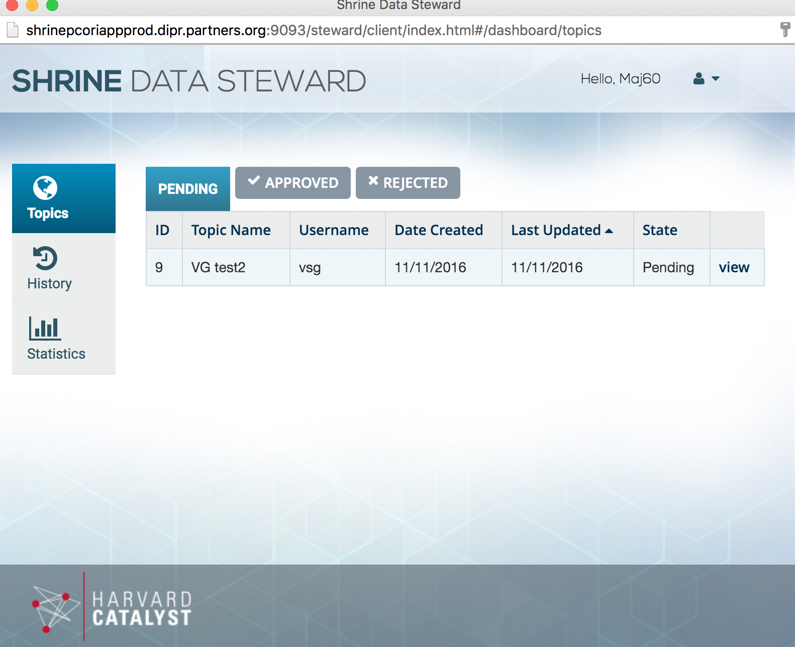

Data Steward Management Step 4: Click on the ‘Approved’ or ‘Rejected’ menus to see which topics have been approved and which ones have been rejected. In SCILHS, by default all query topics are auto-approved.

Data Steward Management, Step 4:

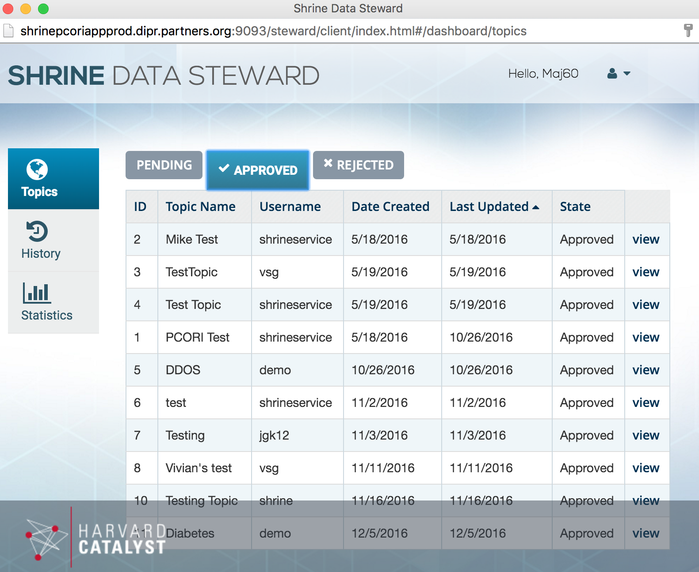

Data Steward Management Step 5: Click ‘view’ at the end of each row to see more details associated with each topic.

Data Steward Management, Step 5:

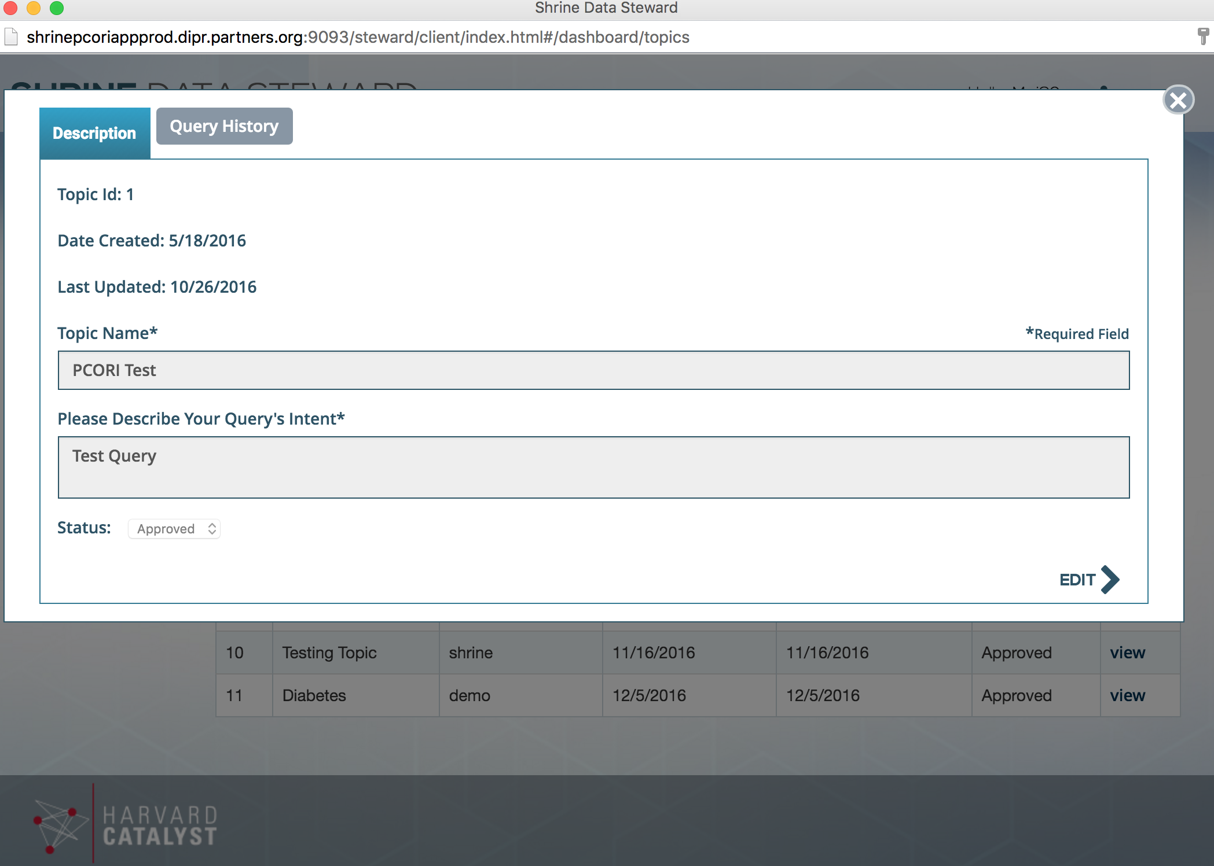

Data Steward Management Step 6: Click on the ‘History’ Menu on the left hand side of the Data Steward Console in order to view the query history in detail as well as what topics are associated with it. History is a great way to look into the query to see details of that query.

Data Steward Management, Step 6:

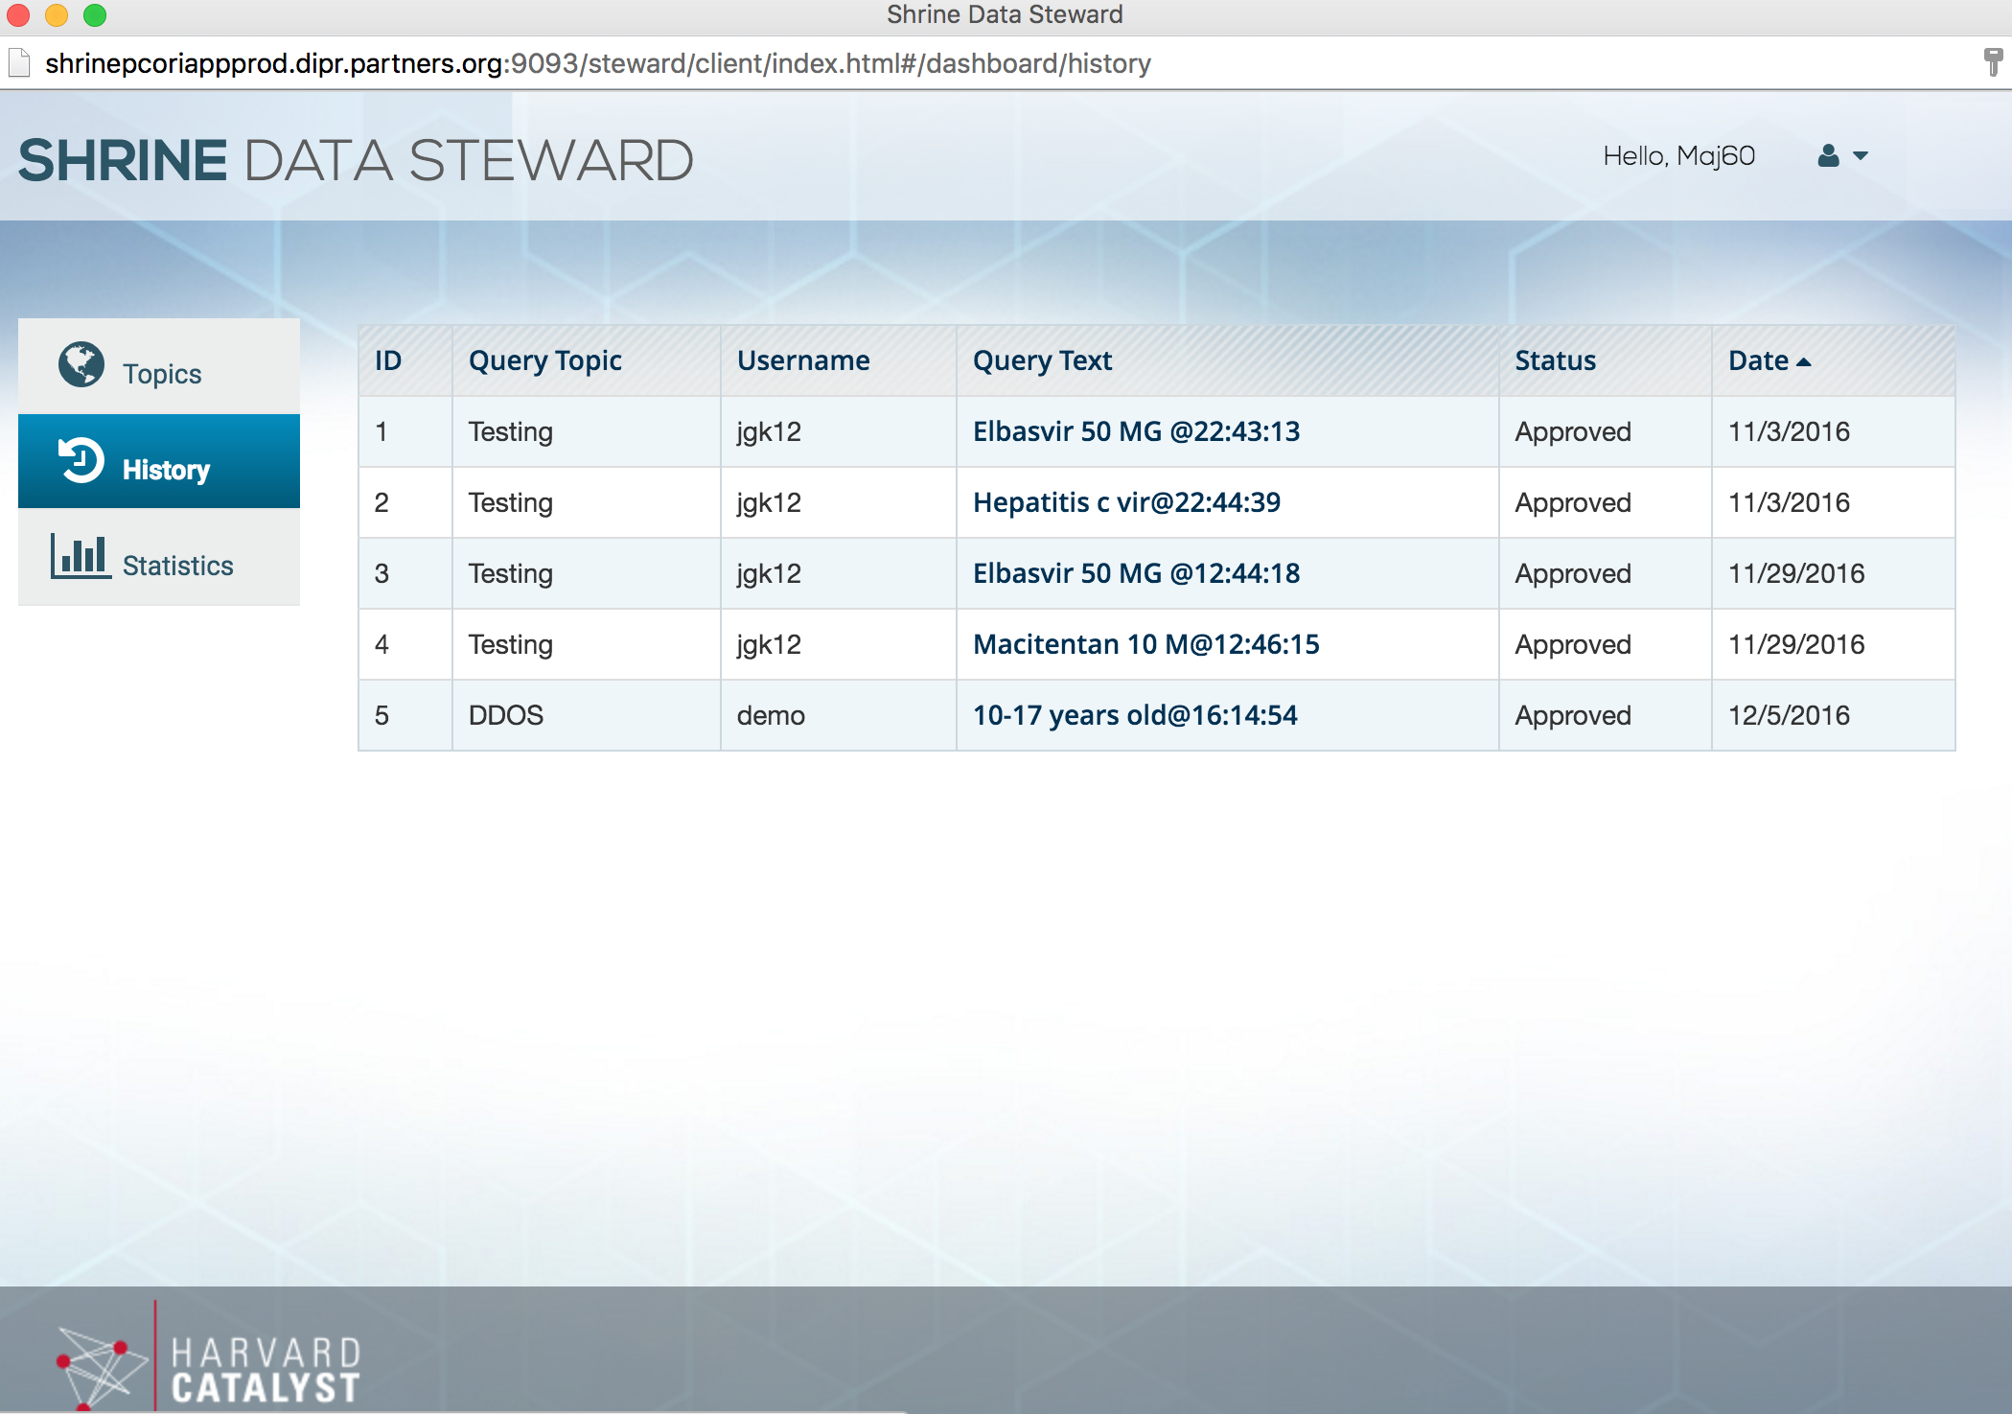

Data Steward Management Step 7: Click on an entry listed in the ‘query text’ column to open a detailed view of the query. The <name> entries will tell you what is being queried.

Data Steward Management, Step 7:

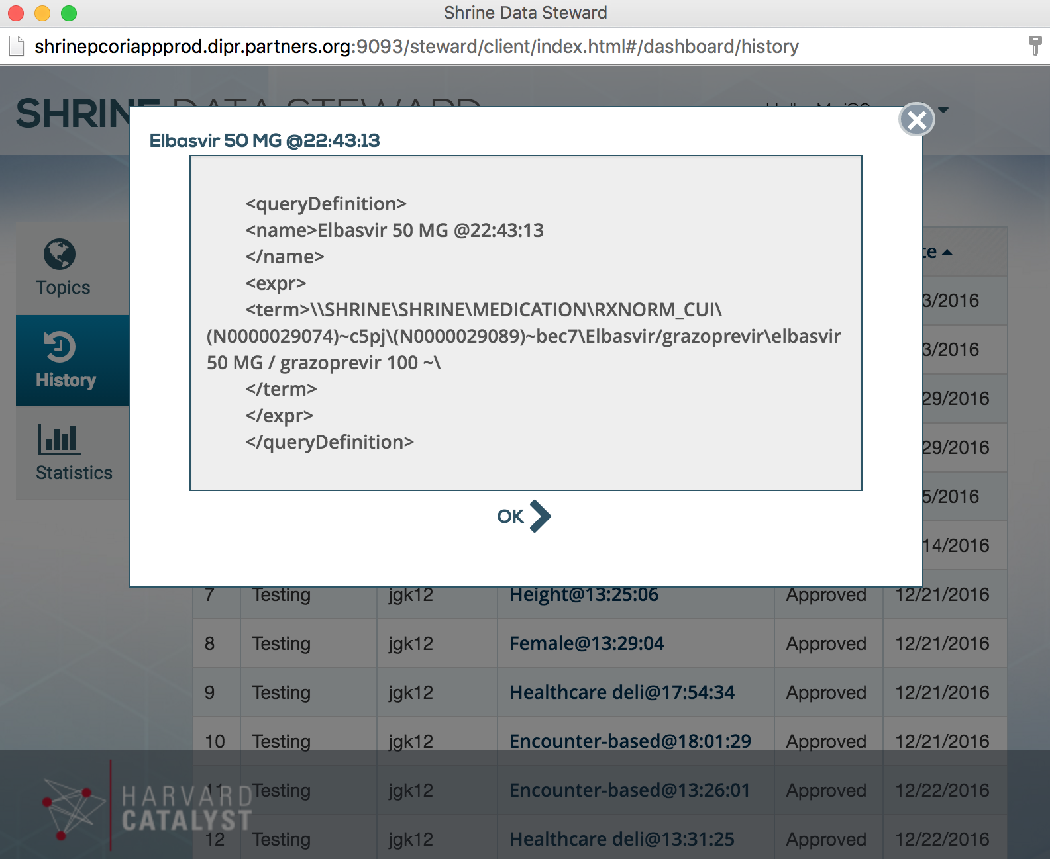

Data Steward Management Step 8: Click on the ‘Statistics’ Menu on the left hand side of the Data Steward Console in order to view statistics gathered on query topics across all users and query count by user. The ‘Start Date’ and ‘End Date’ values may be modified to specify which time period the statistics are integrated over.

Data Steward Management, Step 8:

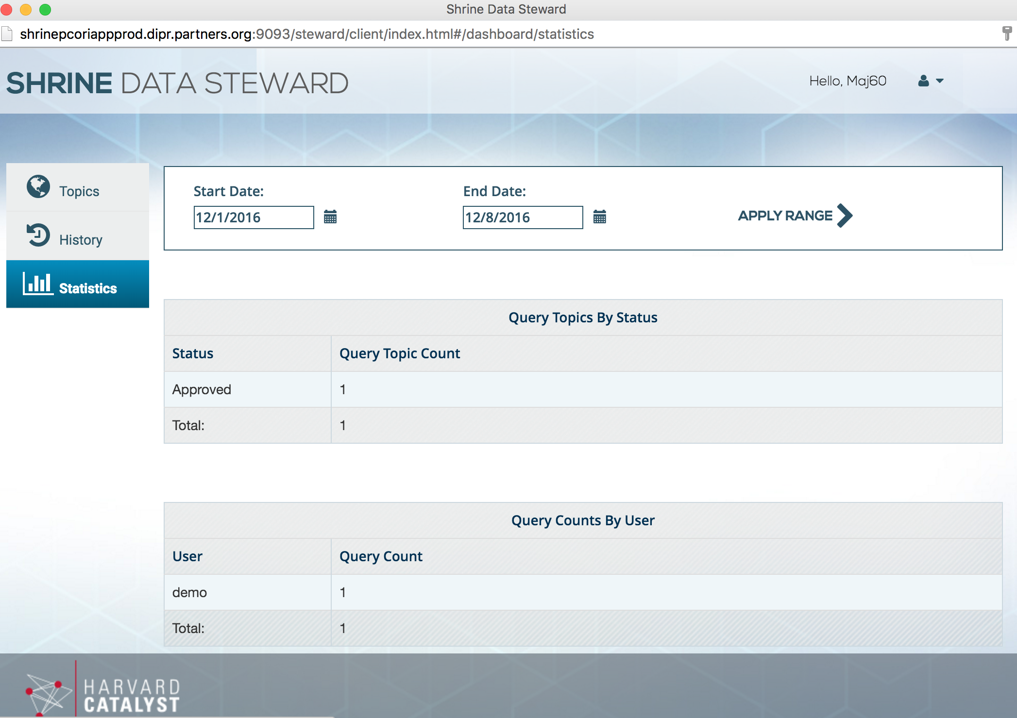

**Using the Data Steward as a ‘User’:**

In SCILHS, all users must associate each query with a relevant query topic for auditing purposes. This section will guide you through creating and choosing a query topic.

Log in to: http://<youri2b2site>/shrine-webclient/# using your standard i2b2 user ID and password. Namely, for Partners, our link would be:

[http://shrinepcoriappprod.dipr.partners.org/shrine-webclient/#](https://owa.partners.org/cvpn/aHR0cHM6Ly9wcm94eS1vd2EucGFydG5lcnMub3Jn/owa/redir.aspx?SURL=LFy5M9CK0BvEcxoiFjO_dJe8SinLyw1KTRrG_gWGPBLu1UEilh_UCGgAdAB0AHAAOgAvAC8AcwBoAHIAaQBuAGUAcABjAG8AcgBpAGEAcABwAHAAcgBvAGQALgBkAGkAcAByAC4AcABhAHIAdABuAGUAcgBzAC4AbwByAGcALwBzAGgAcgBpAG4AZQAtAHcAZQBiAGMAbABpAGUAbgB0AC8AIwA.&URL=http%3a%2f%2fshrinepcoriappprod.dipr.partners.org%2fshrine-webclient%2f%23) .

Select the project associated with SCILHS SHRINE and you will be directed to the web client.

Step 1: In order to run a SHRINE query, it must be associated with a query topic. Previously approved query topics can be selected from the ‘Select and Approved Query Topic’ drop-down menu. Or, a user may click on the ‘Request New Topic’ button near the center of the console to request a new one.

Data Steward User, Step 1:

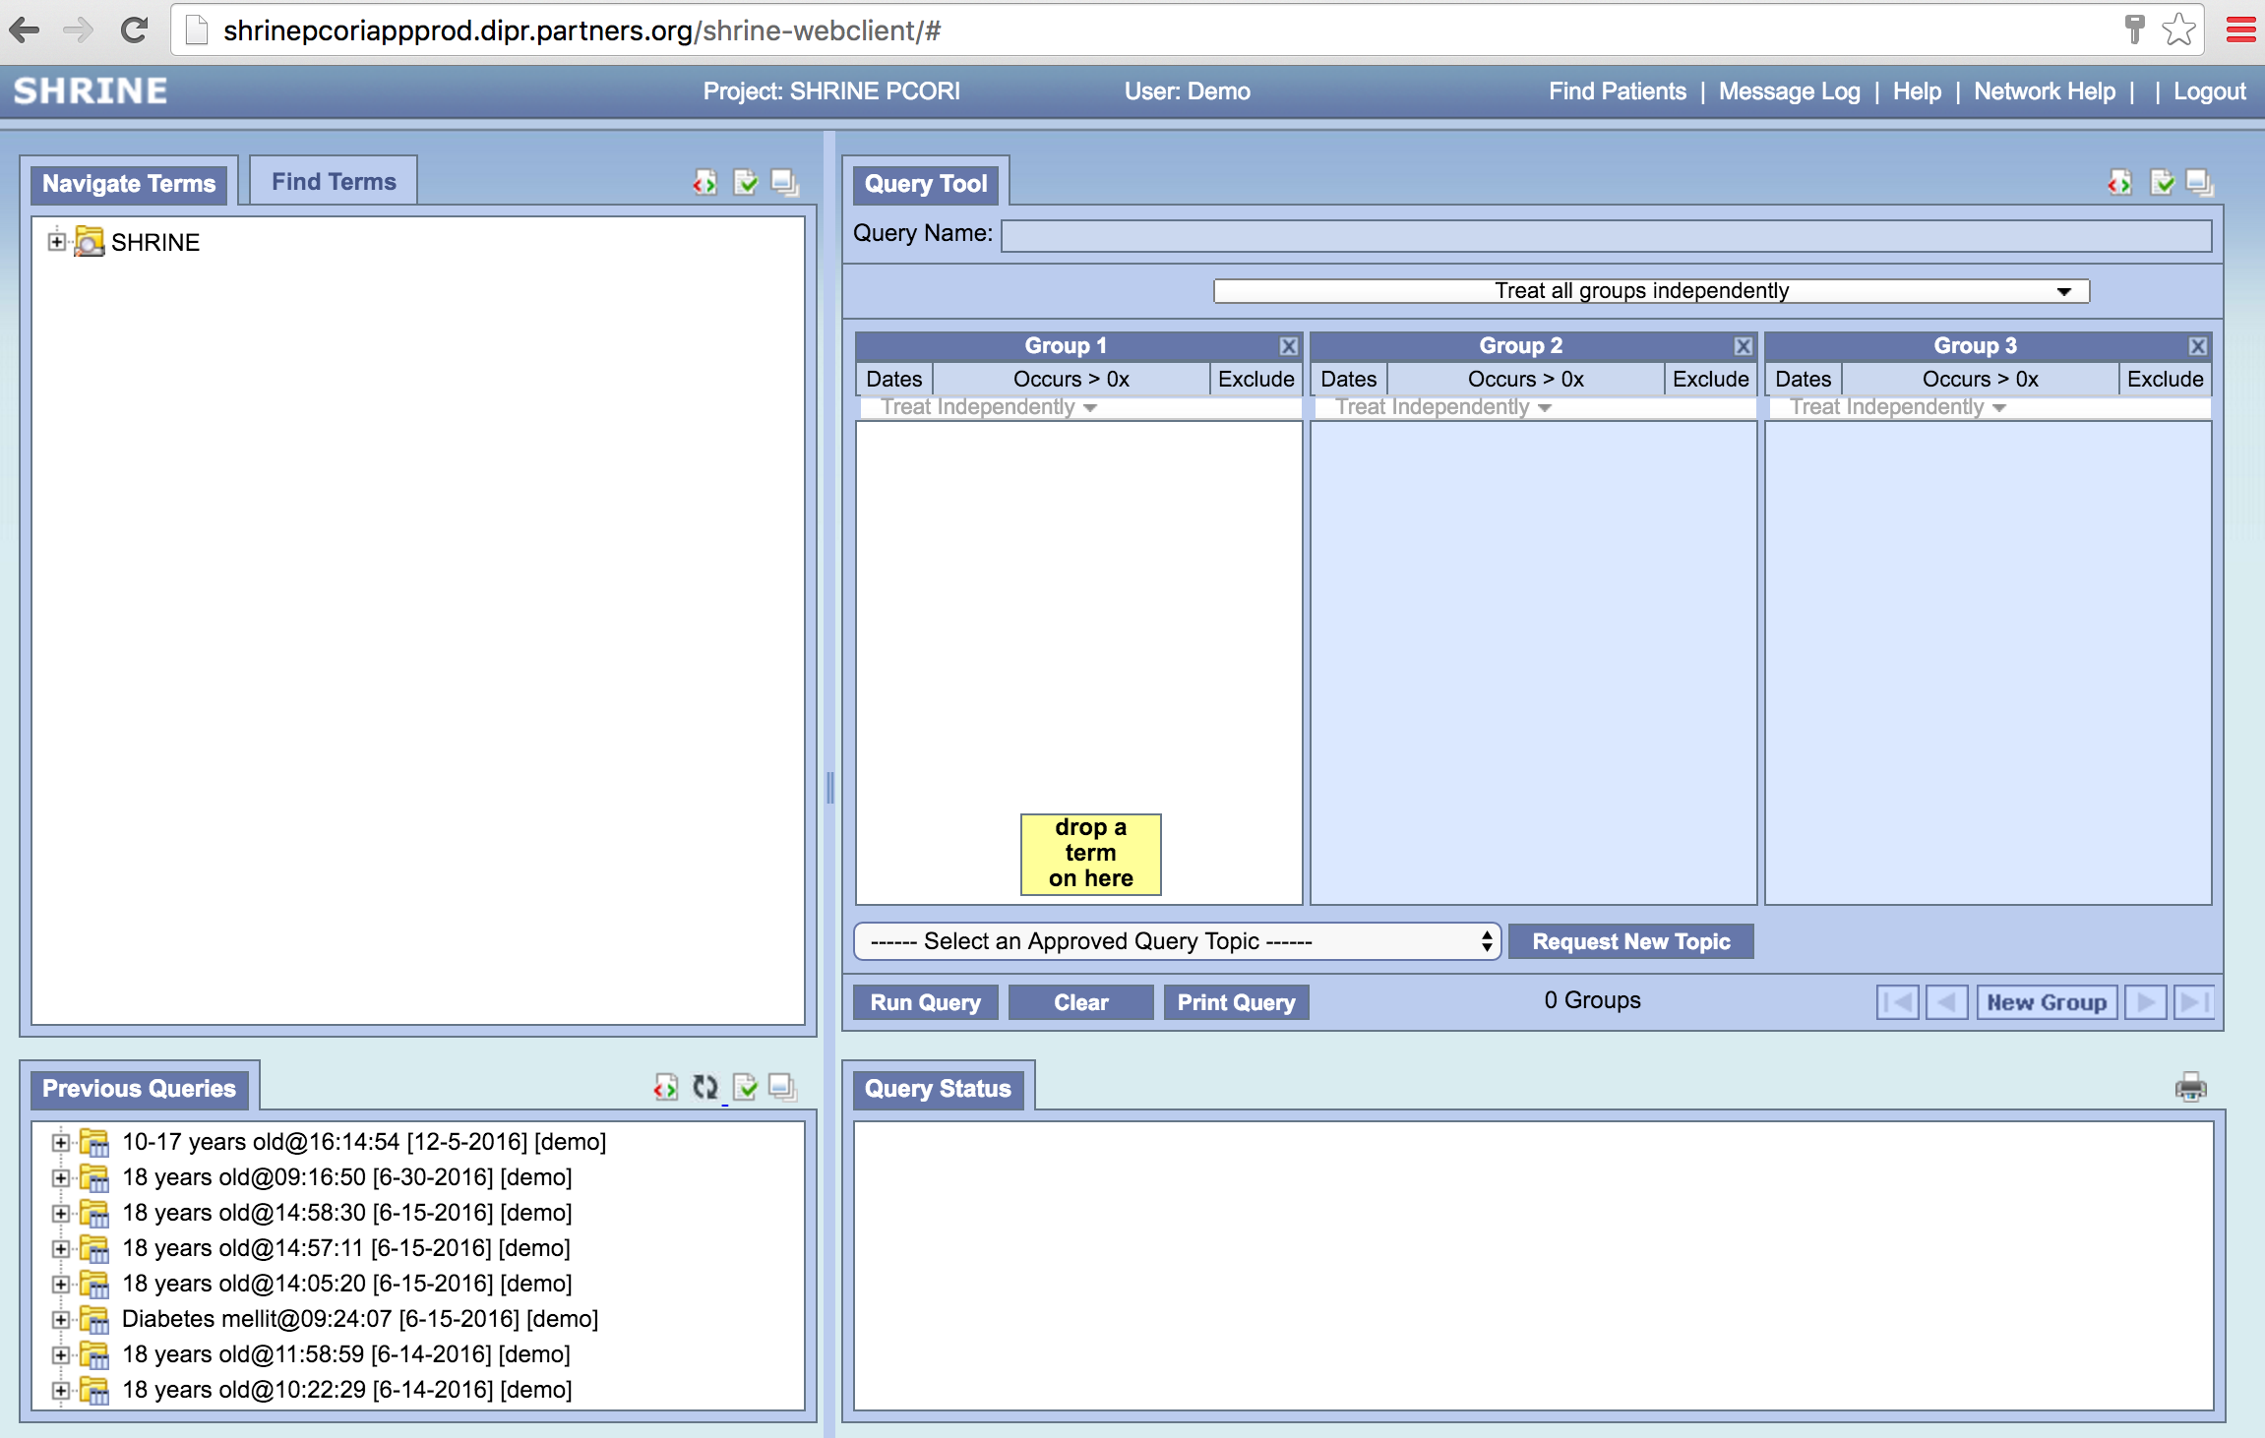

Step 2: The Data Steward window will open. Use your standard i2b2 username and password to log in.

Data Steward User, Step 2:

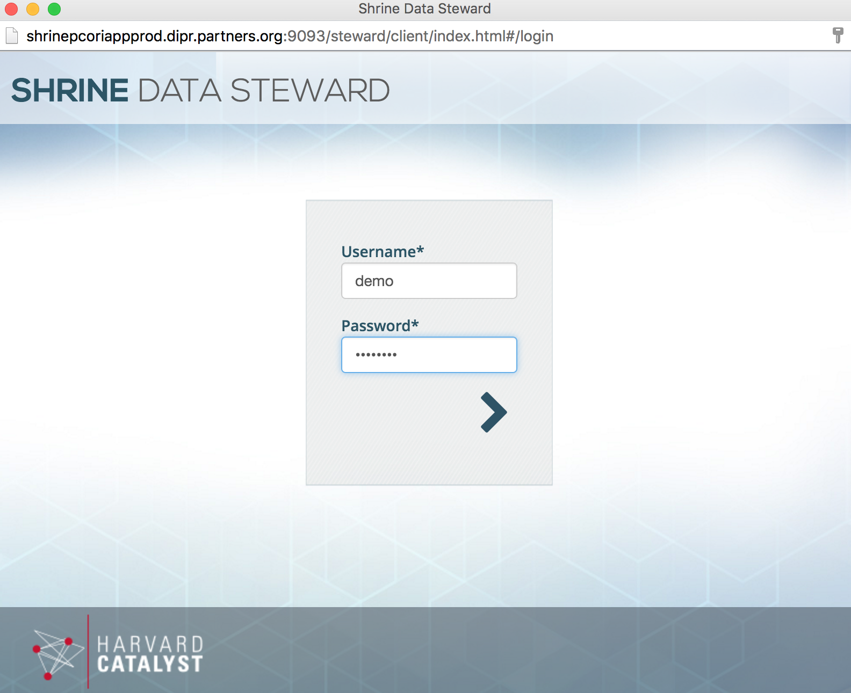

Step 3: Once logged in, a typical user can see a list of topics previously created within the Data Steward. To create a new topic, click on the ‘new’ button / arrow on the right side of the console.

Data Steward User, Step 3:

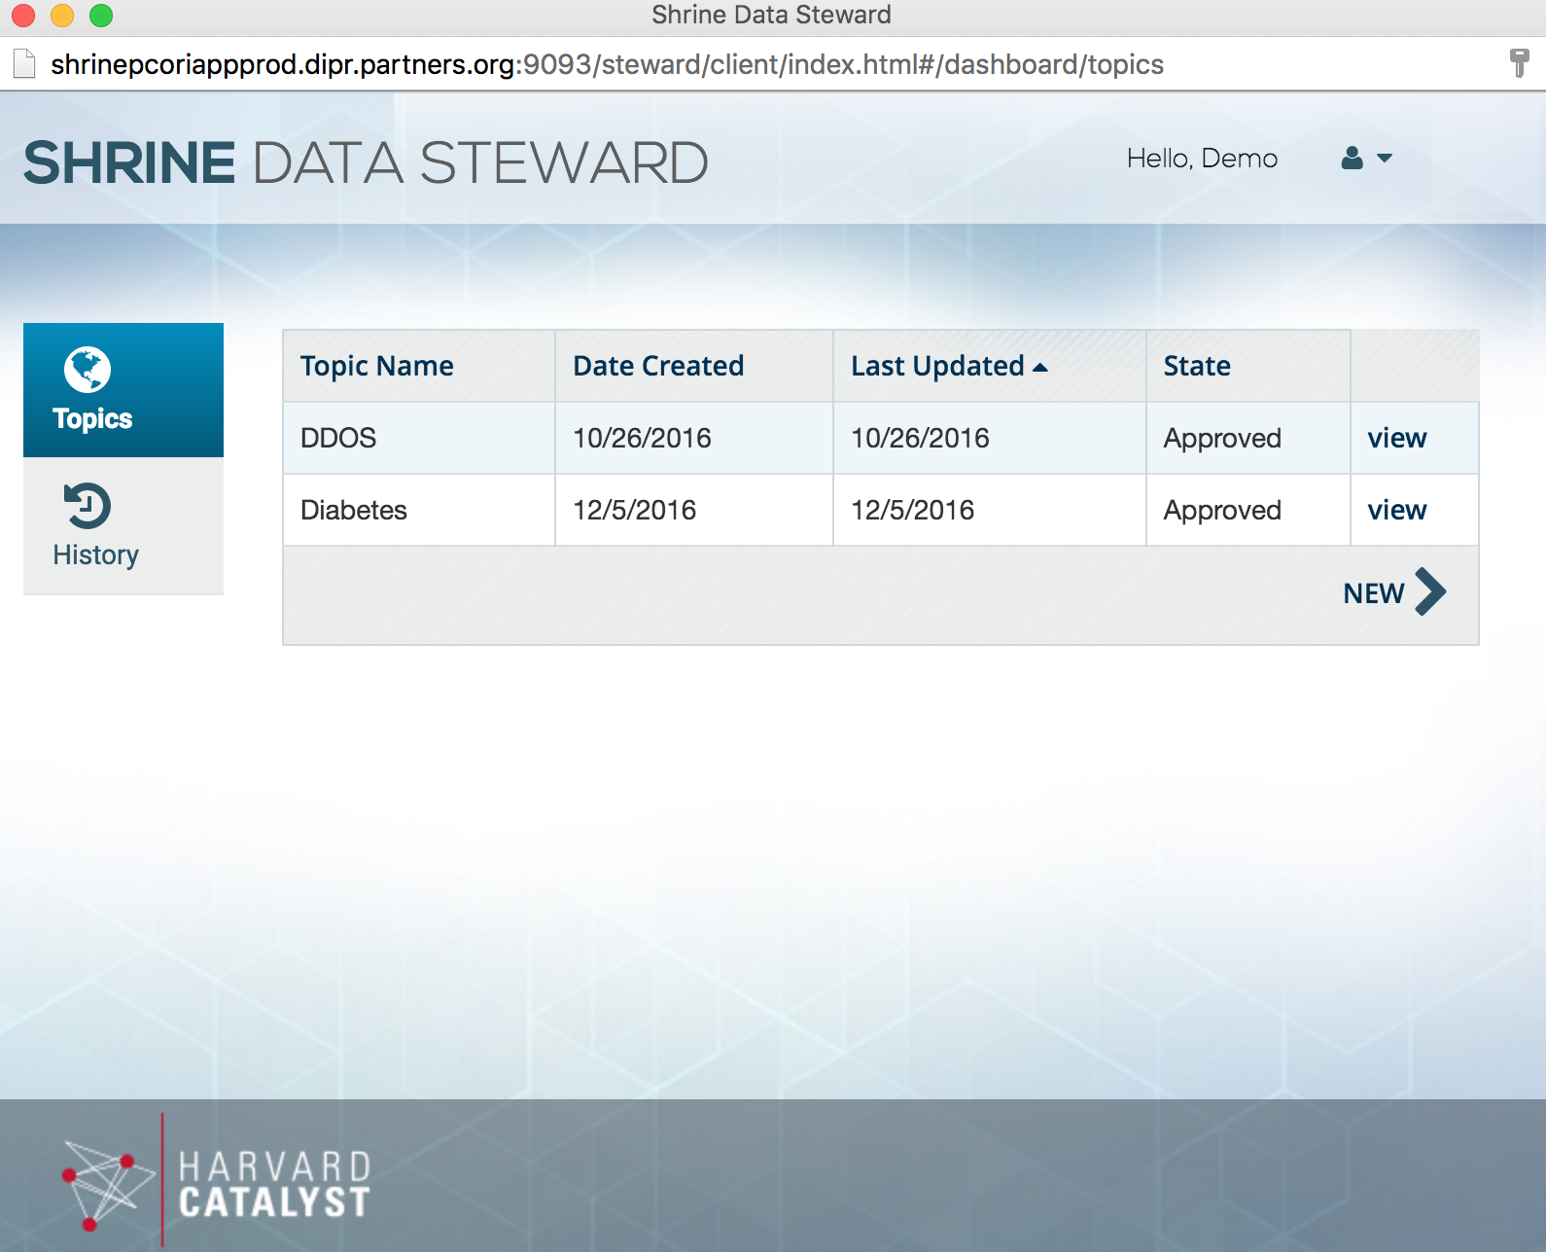

Step 4: Here, you can create a new topic. Enter the topic name, and then enter a description of what your query will do. Make sure that your topic name accurately summarizes this query topic. Click on the ‘Submit’ button to complete the new topic. In the SCILHS network, topics are auto-approved, but they are used for auditing queries. After submission, refresh your i2b2 web client and you will be able to use that topic to run a query.

Data Steward User, Step 4:

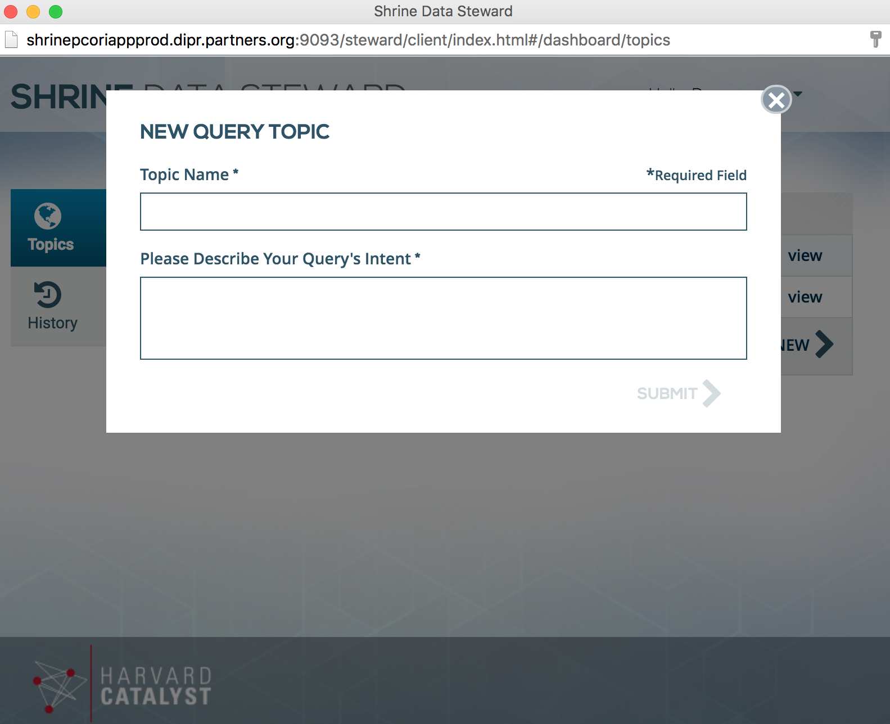

Step 5: A standard user can also view the Data Steward History by clicking on the ‘History’ Button on the left hand side of the Data Steward Console.

Data Steward User, Step 5:

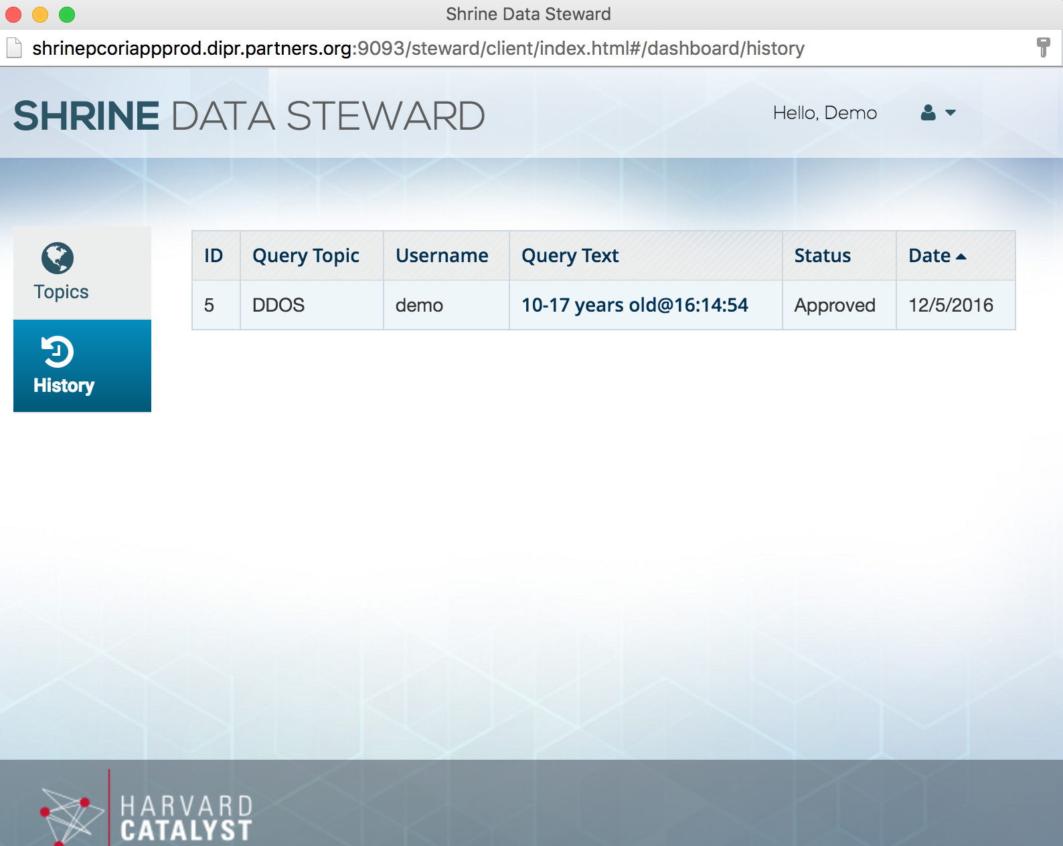

**How to Change your Password:**

To change your password, go to [http://shrine.scilhs.org/webclient](https://outlook.partners.org/owa/redir.aspx?SURL=u-ACYO-N-o83-QipKhK9hBM-bWjXPkTnYNxPEfkUQQaGPhzHsXrUCGgAdAB0AHAAOgAvAC8AcwBoAHIAaQBuAGUALgBzAGMAaQBsAGgAcwAuAG8AcgBnAC8AdwBlAGIAYwBsAGkAZQBuAHQA&URL=http%3a%2f%2fshrine.scilhs.org%2fwebclient) and click “Change password” in the upper right once you log in. Then log out because you can’t do anything there.

**How to Audit the Query Log:**

To run queries / audit the query log, go to [http://shrine.scilhs.org/shrine-webclient](https://outlook.partners.org/owa/redir.aspx?SURL=O8r8VJNlfiybIWLiIxDw1e6tbe-wlVjOYJHIc3tf51qGPhzHsXrUCGgAdAB0AHAAOgAvAC8AcwBoAHIAaQBuAGUALgBzAGMAaQBsAGgAcwAuAG8AcgBnAC8AcwBoAHIAaQBuAGUALQB3AGUAYgBjAGwAaQBlAG4AdAA.&URL=http%3a%2f%2fshrine.scilhs.org%2fshrine-webclient) and log in. Run a query or refer to Matt’s documentation to do Data Steward stuff.